AI ASSISTANT CODING ASSIGNMENT 2

NAME : K.Chaitanya
ROLL NO : 2303A51677
BATCH NO : 22

Task 1: Cleaning Sensor Data
Scenario:
You are cleaning IoT sensor data where negative values are invalid.
Task:
Use Gemini in Colab to generate a function that filters out all negative
numbers from a list.
Expected Output:
Before/after list
Screenshot of Colab execution

OUTPUT:

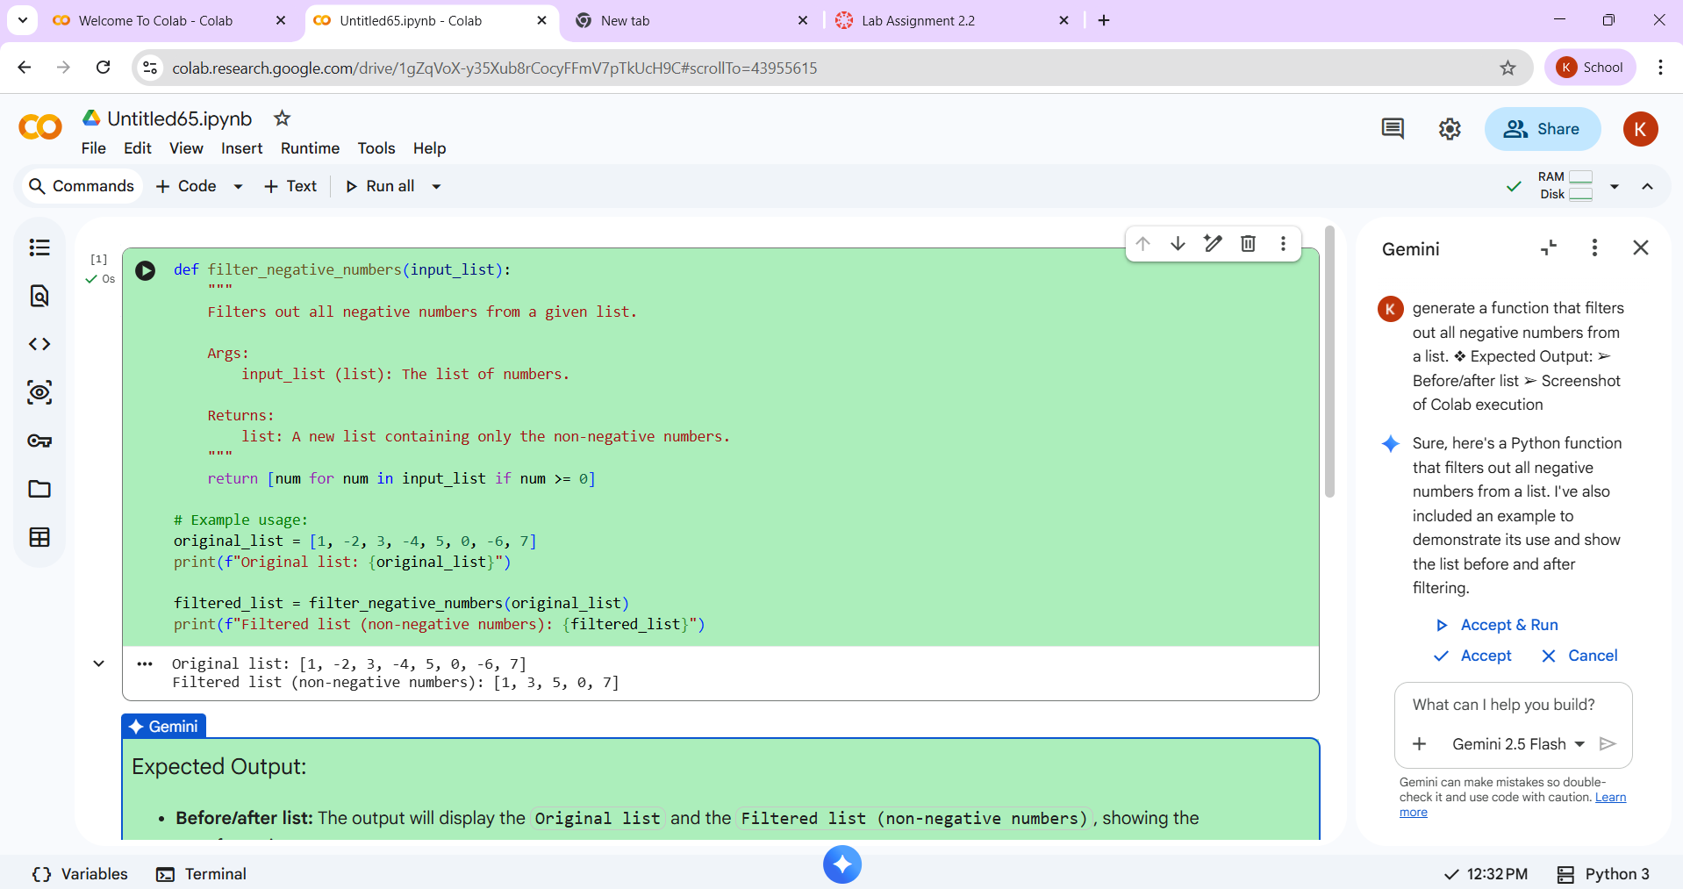

Task 2: String Character Analysis
❖ Scenario:
You are building a text-analysis feature.
❖ Task:
Use Gemini to generate a Python function that counts vowels, consonants,
and digits in a string.
❖ Expected Output:
➢ Working function
➢ Sample inputs and outputs

OUTPUT:

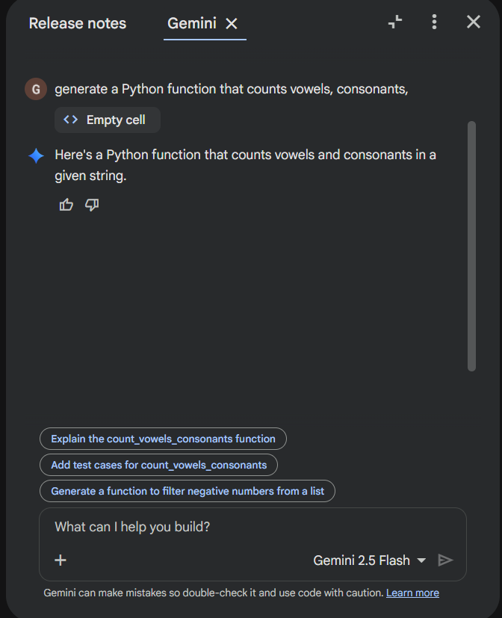

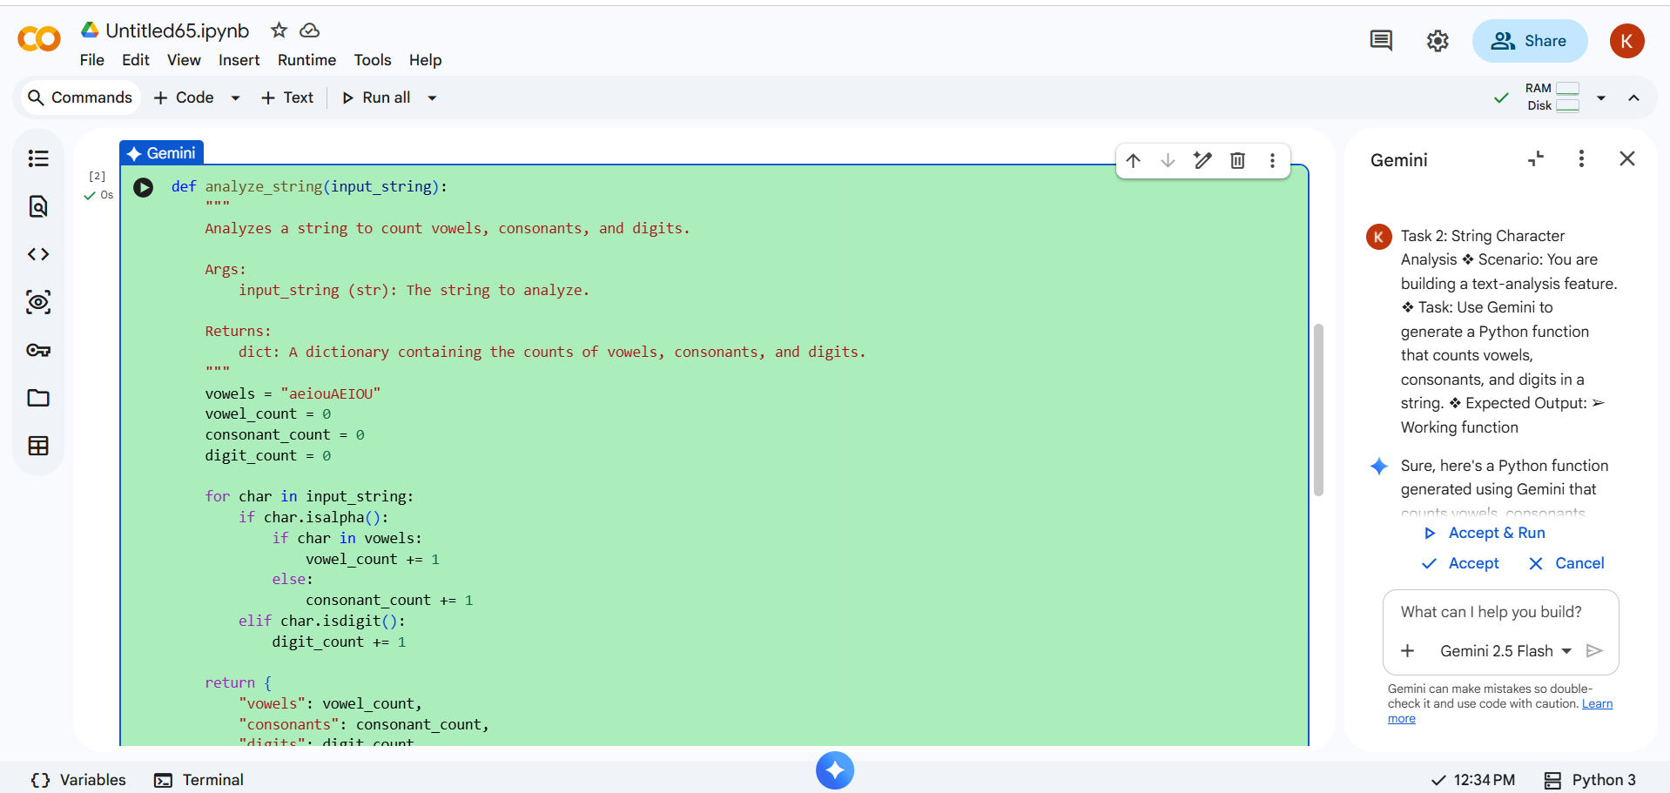

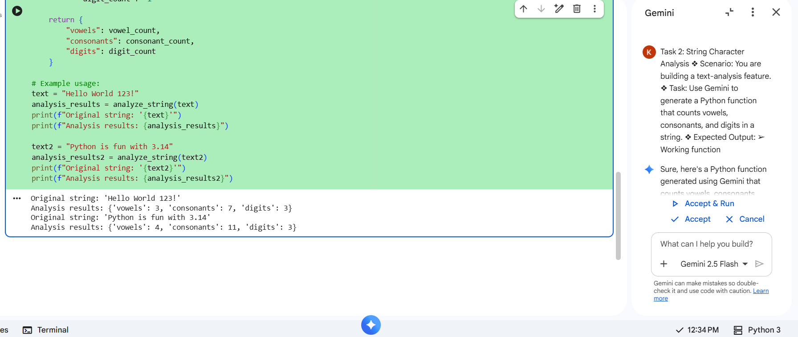

Task 3: Palindrome Check – Tool Comparison
❖ Scenario:
You must decide which AI tool is clearer for string logic.
❖ Task:
Generate a palindrome-checking function using Gemini and Copilot, then
compare the results.
❖ Expected Output:
➢ Side-by-side code comparison
➢ Observations on clarity and structure

Output :

CODE GENERATED BY GEMINI:
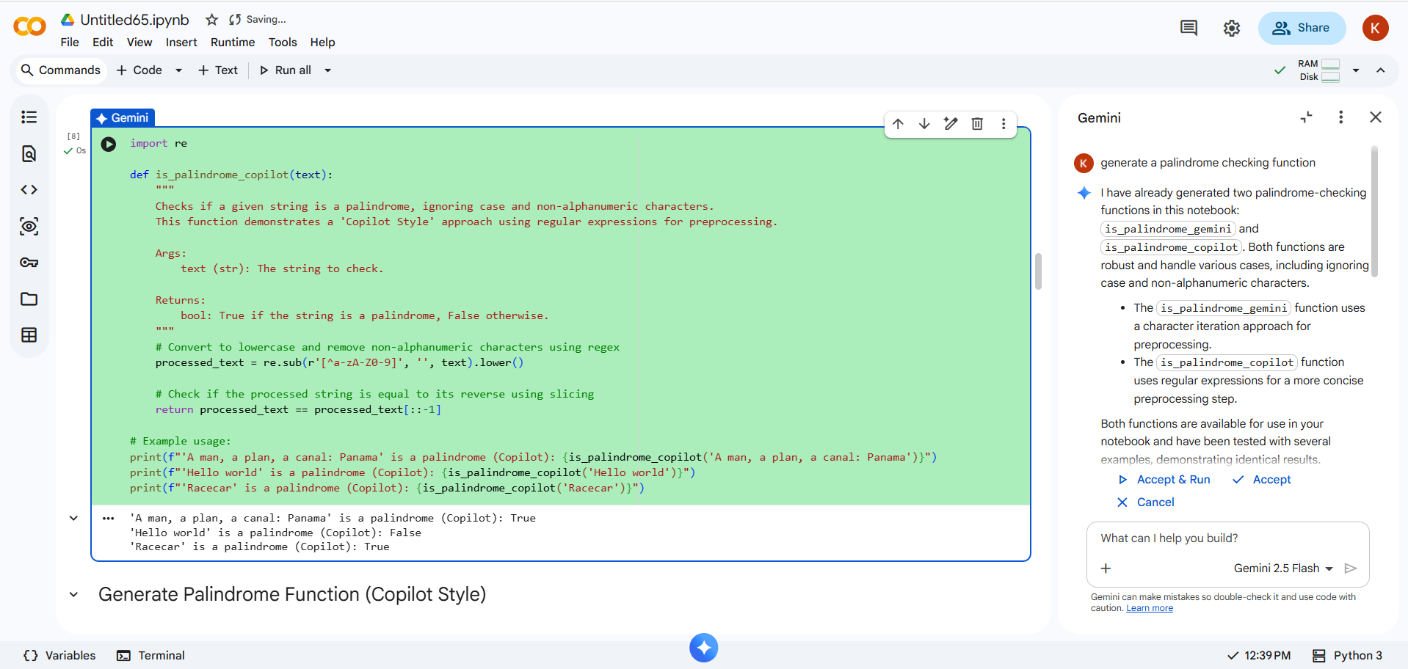

CODE GENERATED BY COPILOT :
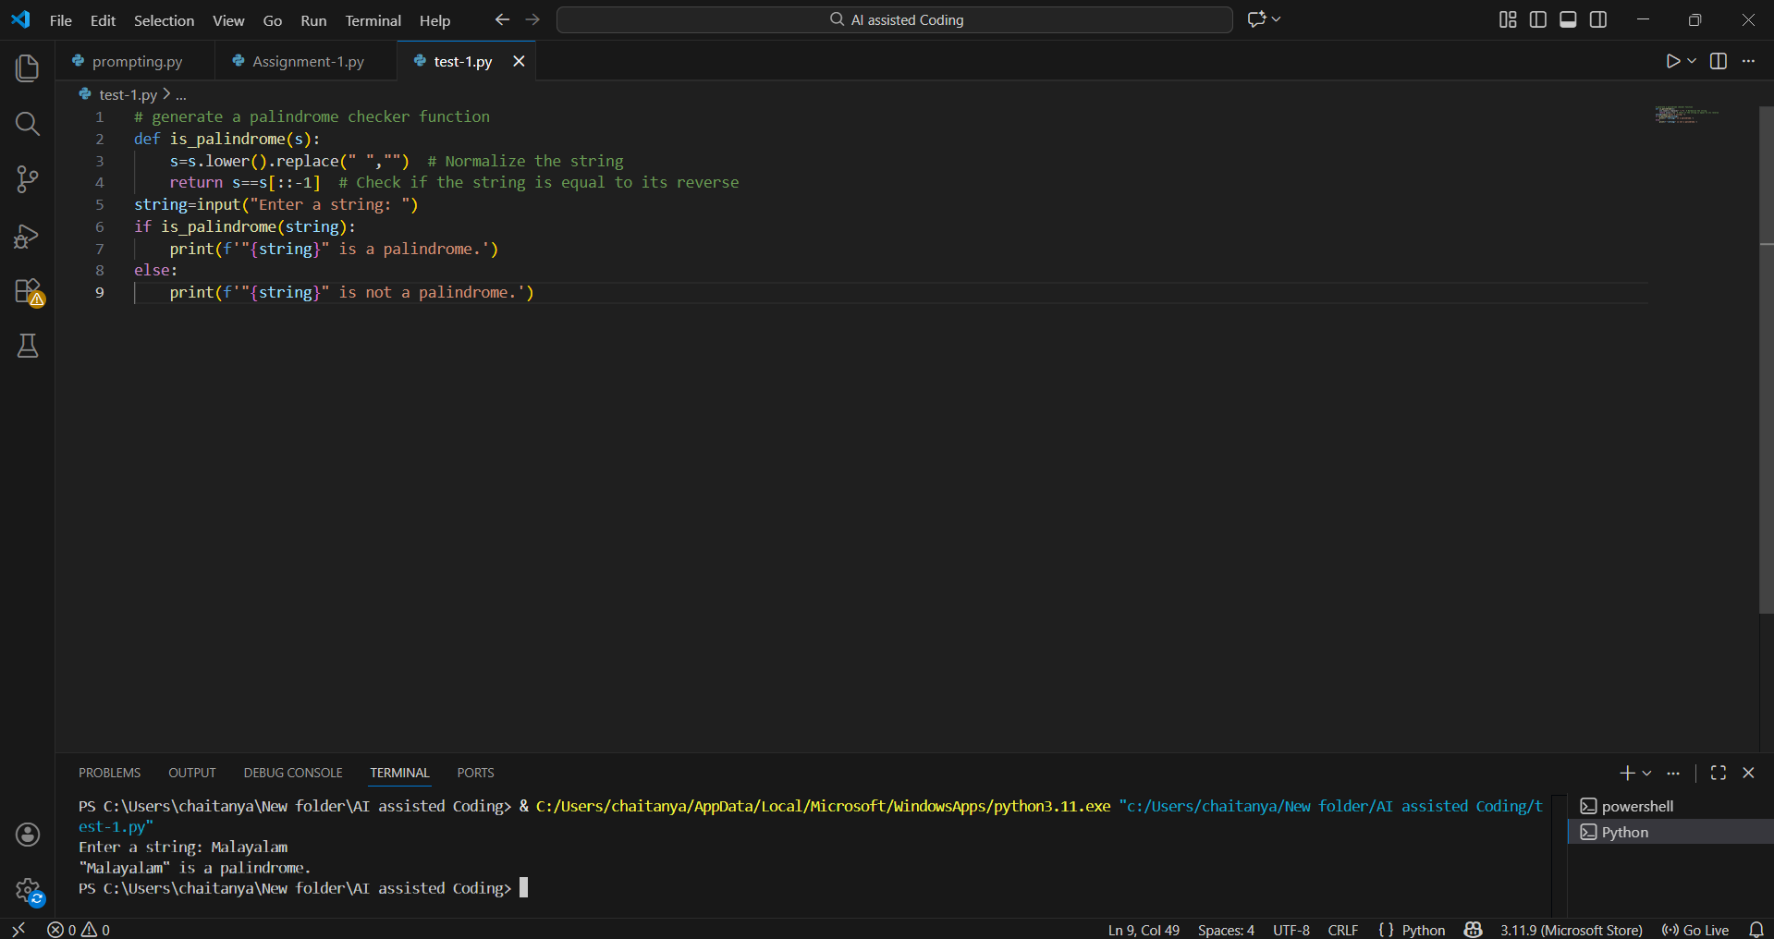

Observations on Clarity:
Gemini Code:
- Highly readable and well-documented.
- Includes a comprehensive docstring that clearly explains the function’s purpose, input parameters, and return value.
- Variable names are descriptive, enhancing code clarity.
- Output is informative, providing context along with results.
Copilot Code:
- Simple and easy to understand, particularly suited for beginners.
- Uses short, functional variable names (e.g., s), which work but lack descriptive clarity.
- Output is minimalistic—returns only True or False without additional context.
- Quick to write, but less explanatory for someone reading the code later.

Observations on Structure

Gemini Code:
- Professionally structured with a reusable function and multiple test cases.
- Robust handling of edge cases, including removal of non-alphanumeric characters and case-insensitive checks.
- Well-organized, making it easy to extend or maintain.
Copilot Code:
- Simple, compact, and straightforward in structure.
- Handles only basic formatting: removing spaces and converting to lowercase.
- Less robust against edge cases, but quick to implement.

Summary
- Gemini’s version is more comprehensive, polished, and ready for broader use.
- Copilot’s version is concise and beginner-friendly, great for learning or quick testing.

Task 4: Code Explanation Using AI
❖ Scenario:
You are reviewing unfamiliar code written by another developer.
❖ Task:
Ask Gemini to explain a Python function (prime check OR palindrome
check) line by line.
❖ Expected Output:
➢ Code snippet
➢ AI explanation
➢ Student comments on understanding

OUTPUT :

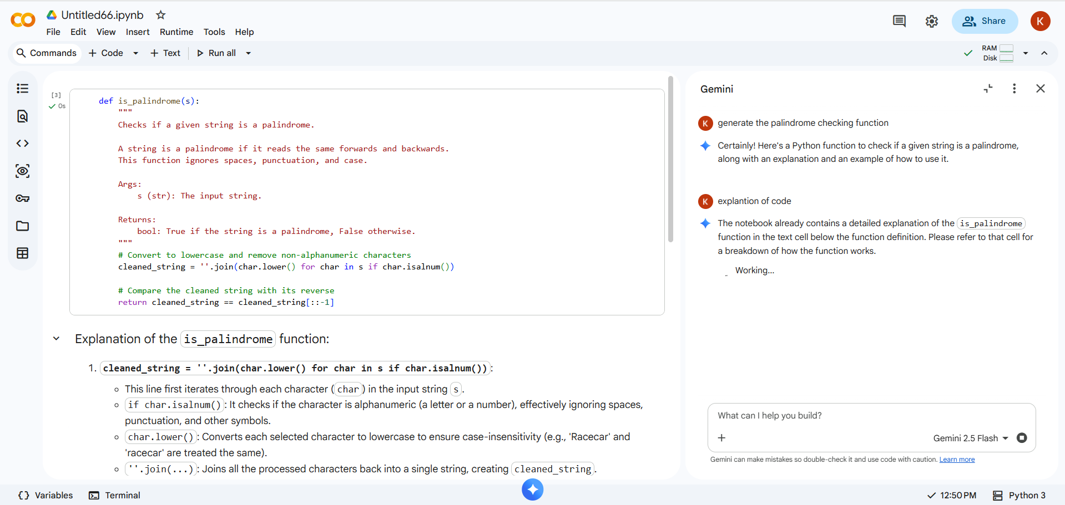

AI Explanation :

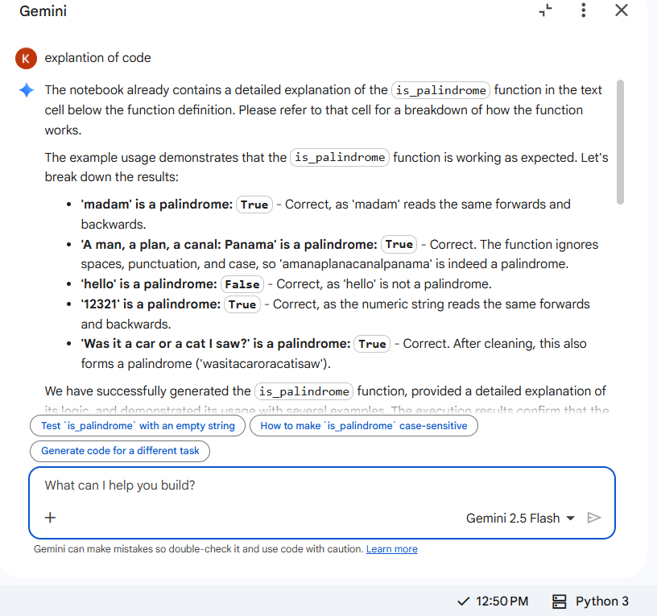

Clear Understanding:
“The explanation was very clear. I now understand how regular expressions are used to clean the string.”
“I get why .lower() is important — it ensures the check is case-insensitive.”
“The slicing trick [::-1] for reversing a string is neat; I hadn’t seen that before.”
“The examples helped me understand how the function works with both simple words and complex phrases.”

